

**Camp Coordination and Camp Management**

Project Document Submitted

To the faculty of School of Computing and Information Technologies of

**ASIA PACIFIC COLLEGE**

In partial requirement for

Software Development

Submitted by: Course Instructor:

Amiel Kristian CuasayMr. Edmundo Casiño

Mary Allyson Bandong

Kent Wendell Curato

Table of Contents

I. Abstract 1

II. Introduction 1

III. Background of the Problem 2

A. Statement of the Problem 2

B. Project Objectives 3

a. General Objectives 3

b. Specific Objectives 3

C. Significance of the Project 4

IV. Scope and Limitations 5

A. Scope of Initial Release 5

B. Limitations 5

V. Analysis and Design 6

A. Process Flow 6

B. Entity Relationship Diagram 7

C. Screenshots of Prototype 12

VI. Proposed Solution 17

VII. Conclusion 18

VIII. References 18

IX. Appendices 18

Appendix 1: Relevant Source Code 18

Appendix 2: Proponents Resume 19

# Abstract

Camp Coordination and Camp Management is a mapping and data viewing module of the system for National Disaster Risk Reduction Management. Which can help Camp and Evacuation Managers to view a map that has the details of camps and evacuation centers. Summary features are geolocation, google map, viewing of camp and evacuation center details and request for tent form and registration and list of evacuees. The team aims to address:

* Safety
* Camp Coordination and Camp Management module is created to ensure the safety of IDPs because it would be easier for them to find shelter as one of the features of this module is the viewing of camps and evacuation center details which consists of photos of evacuation center, address and amenities.
* Mismanagement of the deployment of IDPS
* Lack of coordination is the number one problem during the deployment of IDPs that it creates chaos that IPDs don’t want to leave their homes to evacuate. With these in mind, Camp Coordination and Camp Management module enables the user to pick an evacuation center or a camp that best suites the IDP.

# Introduction

Natural Disasters are very rampant in our times due to natural or manmade events wherein communities experience severe damage and danger. This fortuitous events cause many lives and also damage to properties that will give the community that has been struck by natural disasters a hard time to stand on their own again. Disasters can be less damaging if there is a system that will help the management of the IDP’s (Internally Displaced Persons) in faster administering and management of resources.

Now, in disasters, Camp Coordination and Camp Management is a very essential component of the Disaster Operations. Because this cluster ensures equitable access to services and protection for displaced persons living in communal settings. Also, their aim is to improve the quality of life and dignity of IDP’s during displacement and advocate for solutions while preparing them for life after displacement.

# Background of the Problem

Based on the group’s research of the problem, the reason why the Philippines is prone to typhoons, floods, landslides, volcanic eruptions, earthquakes and tsunamis is because of its location along the Ring of Fire or typhoon belt – a Pacific Ocean region where many Earth’s volcanic eruptions and earthquake occur. Making the Philippines a vulnerable place for natural disasters. This problem needs to be addressed as soon as possible by prevention or mitigation.

## **Statement of the Problem**

There are four main problems of the camp coordination and camp management that the system will address. **First, evacuation and camp location.** Addressing this kind of problem will help the evacuation and camp managers to give an accurate information on where to put IDPs in a safe and secure shelter. **Second, recreational and other essential information.** In a camp or in an evacuation center, it is important to have a recreational like: Home for the aged or a daycare and as for the other information, things like: toilets, showers, kitchens, and beddings, etc... are included too. **Third, tent request.** In a camp, it must have a several number of tents to accommodate all IDPs. Also, the cluster should also consider the shortage of tents, so camp coordination and camp management cluster must create a tent request process**. Lastly, registration of evacuees.** All shelters must have registration of evacuees to keep track of the population inside a camp or evacuation centers. The CCCM cluster must provide additional essential fields like: age, departure date and departure time.

## **Proposed Solution**

The proposed solution is to a create a web-application system that will address the four main problems of the cluster. The following are the proposed features of the system:

**Mapping**

The system will provide a mapping module that uses Google Maps. This map will display 3 markers that represents: camp, evacuation center, and the user. The camp and evacuation center markers will display essential details like: population of the shelter, toilets, beddings, medical supplies, needed personnel, etc. Lastly, the map uses geolocation for locating the user.

**Request for Tent**

A request for tent form will be included in the system managed by the camp manager.

**Registration of Evacuees**

The system will provide a listing of all registered evacuees and a registration form is present managed by a camp or evacuation center manager.

## **Recommendation**

* Since the system uses Google Maps, it will require internet connection for rendering the map
* Any devices that can connect to the internet such as: desktops or laptops will do since this is a web-application.

## **Project Objectives**

### **General Objectives**

* + To ensure equitable access to services and protection for Internally Displaced Persons living in communal settings.

### **Specific Objectives**

* + To provide people information on where to find the camps and the evacuation centers including the details of it.
  + To ensure that facilities are safe, secure and accessible for all potential IDPs.
  + To ensure the establishment of accurate sex and age disaggregated data e.g. listing and profiling of IDPs inside an evacuation centers or camps.
  + To ensure that all IDPs inside an evacuation centers are provided with basic humanitarian needs.
  + To ensure the availability of security, health and animal control personnel.
  + To ensure the segregation of IDPs, livestock and pet animals.

## **Significance of the Project**

This project promotes the use of technology to provide information of Camps and Evacuation Centers to all camp and evacuation center managers.

## **Proposed Modules**

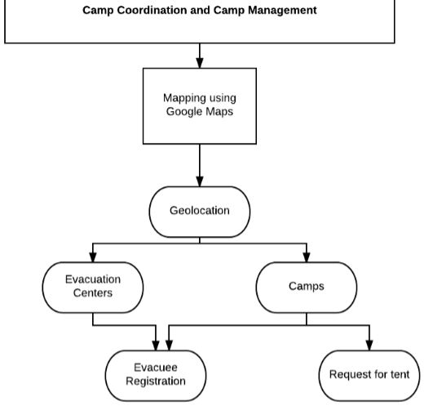

# Scope and Limitations

## **Scope of Initial Release**

The initial release of “Camp Coordination and Camp Management” web application will have the following features:

* Google Maps Navigation and Geolocation

The application will help camp and evacuation center managers locate a camp or an evacuation center.

* Data Viewing and Listing

This feature will help all camp and evacuation center managers get the information of camps or evacuation center.

* Request for tent form

This feature will help camp managers to organize and manage the site by requesting and deploying additional tents.

* Evacuee registration form

This feature will help all camp and evacuation center managers to keep track and manage people inside the building.

## **Limitations**

The following are the constraints/ limitations of Camp Coordination and Camp Management web application:

* Internet Connectivity and Signal

Google Maps: without the internet, the map will not load.

* QGIS (Quantum Geographic Information System) Mapping

This software is a cross-platform free and open-source desktop geographic information system that provides offline mapping

***Reasons for not using QGIS Mapping:***

* The time it takes to render the whole map when offline
* Inaccurate coordinates
* Limited and outdated software demonstration

***Reasons for using Google Maps:***

* Fast rendering of map (still depends on the internet)
* Easy to embed on web applications
* Updated software demonstration
* Map customization is easy to use
* Application response time

The response time is dependent on the user’s device.

* Accuracy of GPS Location

The accuracy of the location is dependent on the device’s GPS.

# Analysis and Design

## **Process Flow**

## **Entity Relationship Diagram**

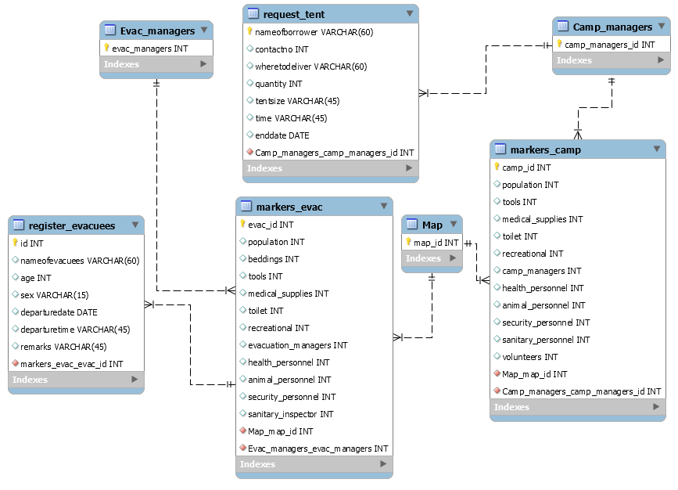

## **Data Dictionary**

|  |  |  |  |  |  |  |
| --- | --- | --- | --- | --- | --- | --- |
| **Markers_evac** | | | | | | |
| **FIELD NAME** | **DATA TYPE** | **FIELD SIZE** | **KEY** | **NULLABILITY** | **DESCRIPTION** | **SAMPLE DATA** |
| **evac_id** | int | 11 | PK | NN | Unique identification number for evacuation centers | 1 |
| **population** | int | 20 |  | NN | Number of evacuees inside a building | 2,342 |
| **beddings** | int | 11 |  | NN | Number of beddings | 500 |
| **tools** | int | 11 |  | NN | Number of tools | 100 |
| **medical_supplies** | int | 11 |  | NN | Number of medical supplies | 1000 |
| **toilet** | int | 11 |  | NN | Number of toilets | 50 |
| **recreational** | int | 11 |  | NN | Number of amenities or recreational | 2 |
| **evacuation_managers** | int | 11 |  | NN | Number of evacuation managers | 2 |
| **health_personnel** | int | 11 |  | NN | Number of health personnel | 20 |
| **animal_personnel** | int | 11 |  | NN | Number of animal personnel | 4 |
| **security_personnel** | int | 11 |  | NN | Number of security personnel | 40 |
| **sanitary_personnel** | int | 11 |  | NN | Number of sanitary personnel | 2 |
| **Map_map_id** | int | 11 | FK | NN | Unique identification number for map | 1 |
| **Evac_centers_evac_managers** | int | 11 | FK | NN | Number of Evacuation center manager | 2 |

|  |  |  |  |  |  |  |
| --- | --- | --- | --- | --- | --- | --- |
| **Markers_camp** | | | | | | |
| **FIELD NAME** | **DATA TYPE** | **FIELD SIZE** | **KEY** | **NULLABILITY** | **DESCRIPTION** | **SAMPLE DATA** |
| **camp_id** | int | 11 | PK | NN | Unique identification number for evacuation centers | 1 |
| **population** | int | 20 |  | NN | Number of evacuees inside a building | 5,342 |
| **tools** | int | 11 |  | NN | Number of tools | 100 |
| **medical_supplies** | int | 11 |  | NN | Number of medical supplies | 500 |
| **toilet** | int | 11 |  | NN | Number of toilets | 50 |
| **recreational** | int | 11 |  | NN | Number of amenities or recreational | 2 |
| **camp_managers** | int | 11 |  | NN | Number of evacuation managers | 2 |
| **health_personnel** | int | 11 |  | NN | Number of health personnel | 25 |
| **animal_personnel** | int | 11 |  | NN | Number of animal personnel | 4 |
| **security_personnel** | int | 11 |  | NN | Number of security personnel | 40 |
| **sanitary_personnel** | int | 11 |  | NN | Number of sanitary personnel | 1 |
| **Volunteers** | int | 11 |  | NN | Number of volunteers | 35 |
| **Map_map_id** | int | 11 | FK | NN | Unique identification number for map | 1 |
| **Camp_managers_camp_managers** | int | 11 | FK | NN | Number of Camp center manager | 2 |

|  |  |  |  |  |  |  |
| --- | --- | --- | --- | --- | --- | --- |
| **Map** | | | | | | |
| **FIELD NAME** | **DATA TYPE** | **FIELD SIZE** | **KEY** | **NULLABILITY** | **DESCRIPTION** | **SAMPLE DATA** |
| **map_id** | cnt | 11 | PK | NN | Unique identification number for map | 1 |

|  |  |  |  |  |  |  |
| --- | --- | --- | --- | --- | --- | --- |
| **Camp_managers** | | | | | | |
| **FIELD NAME** | **DATA TYPE** | **FIELD SIZE** | **KEY** | **NULLABILITY** | **DESCRIPTION** | **SAMPLE DATA** |
| **camp_managers** | int | 11 | PK | NN | Unique identification number for camp managers | 1 |

|  |  |  |  |  |  |  |
| --- | --- | --- | --- | --- | --- | --- |
| **Evacuation_managers** | | | | | | |
| **FIELD NAME** | **DATA TYPE** | **FIELD SIZE** | **KEY** | **NULLABILITY** | **DESCRIPTION** | **SAMPLE DATA** |
| **evacuation_managers** | int | 11 | PK | NN | Unique identification number for evacuation managers | 1 |
| **Request_tent** | | | | | | |
| **FIELD NAME** | **DATA TYPE** | **FIELD SIZE** | **KEY** | **NULLABILITY** | **DESCRIPTION** | **SAMPLE DATA** |
| **nameofborrower** | varchar | 60 | PK | NN | Name of borrower | Jane Doe |
| **contactno** | int | 11 |  | NN | Contact number of borrower | 09235678999 |
| **wheretodeliver** | varchar | 60 |  | NN | Place where to deliver | Mercedes Elementary School |
| **tentsize** | varchar | 60 |  | NN | Size of tent | Large |
| **enddate** | date |  |  | NN | Duration of tent | |  |  | | --- | --- | | 2017-03-03 |  | |
| **quantity** | int | 11 |  | NN | Quantity of tent | 3 |
| **timeofdeliver** | varchar | 10 |  | NN | Time of delievery | 05:00 AM |
| **Camp_managers_camp_managers_id** | int | 11 | FK | NN | Unique identification number for camp managers | 1 |

|  |  |  |  |  |  |  |
| --- | --- | --- | --- | --- | --- | --- |
| **Register_evacuees** | | | | | | |
| **FIELD NAME** | **DATA TYPE** | **FIELD SIZE** | **KEY** | **NULLABILITY** | **DESCRIPTION** | **SAMPLE DATA** |
| **id** | int | 11 | PK | NN | Unique identification number for an evacuee | 1 |
| **nameofevacuees** | varchar | 60 |  | NN | Name of evacuee | John Galt |
| **age** | int | 11 |  | NN | Age of evacuee | 30 |
| **sex** | varchar | 10 |  | NN | Sex of an evacuee | Male |
| **departuredate** | date |  |  | NN | Date of departure | |  |  | | --- | --- | | 2017-04-05 |  | |
| **departuretime** | varchar | 10 |  | NN | Time of departure | 07:00 PM |
| **remarks** | varchar | 255 |  | NN | Comments/remarks for an evacuee | N/A |
| **markers_evac_evac_id** | int | 11 | FK | NN | Unique identification number for evacuation center | 1 |

## **Screenshots of Prototype**

***MAINPAGE***

Since the system is inside the emergency cluster’s dashboard, it will not have a sign up or a login process.

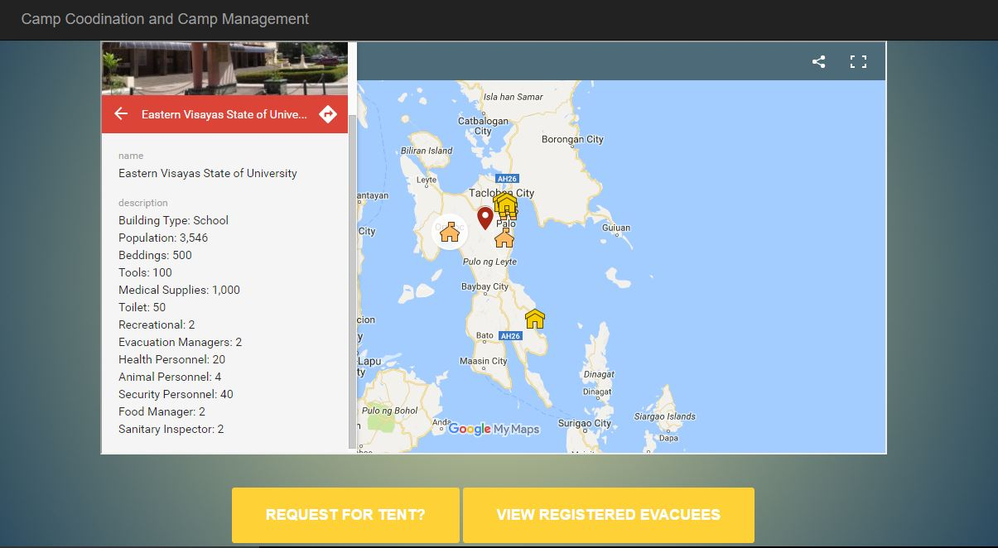This page is used for the Data viewing module wherein camp managers or evacuation center managers will get information from the map.

***MAINPAGE- ( LEGENDS )***

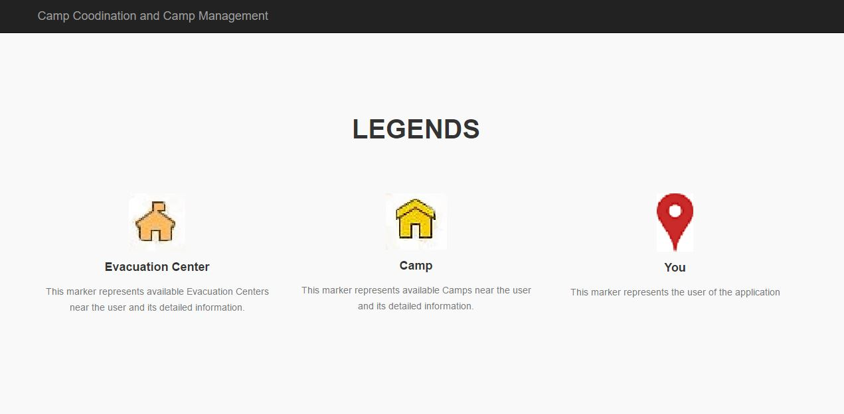This part represents all markers available inside the map.

***REQUEST FOR TENT FORM***

A camp manager can fill up this form that has request specifications by clicking the “Request for tent” button in the main page. Once the “Send” button is clicked, the data entered by the camp manager will be sent to the logistics database.

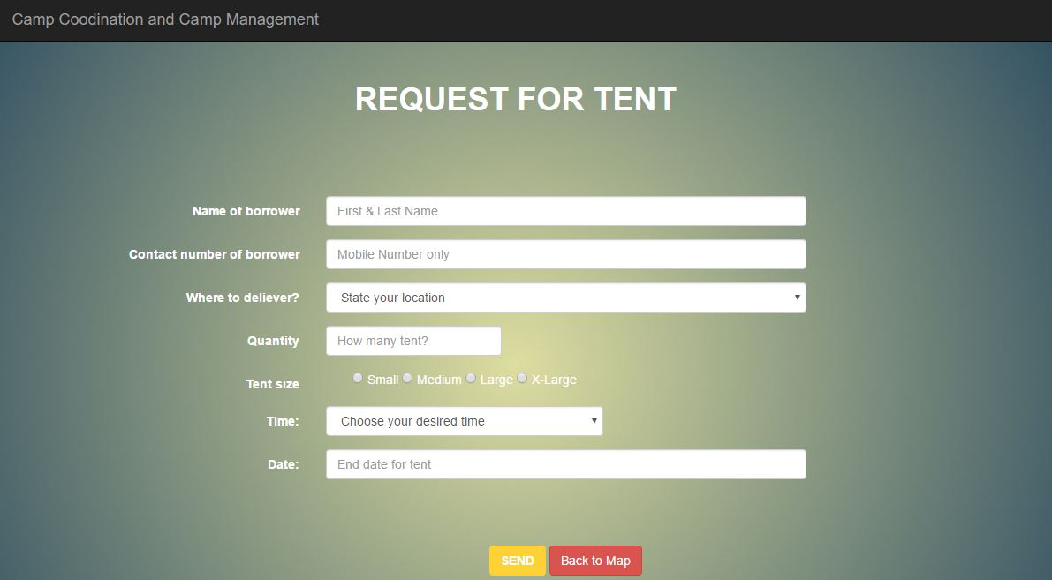

***VIEW EVACUEES RECORD PAGE***

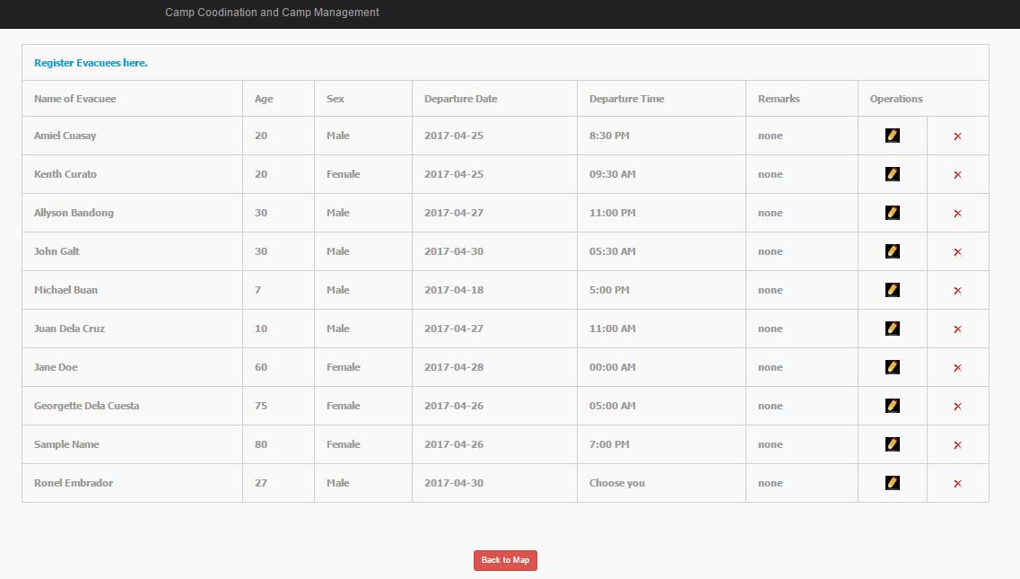 To gain access, the user must click the “View Registered Evacuees” button on the main page. This page is used for the Data Listing with its essential fields. Also, this data table follows the **CRUD** method which are: create, read, update, and delete. The “Register Evacuees here” link is the **create method**, in the left side of the “**Operations**” column there is logo that symbolizes **update record method**, and the right part is the **delete method.**

***REGISTER EVACUEE FORM***

To gain access, the user must click “Register Evacuees here “button. This page is used for the registration of evacuees with its essential fields. Once the “Save” button is clicked, the data entered will be stored in the data list table.

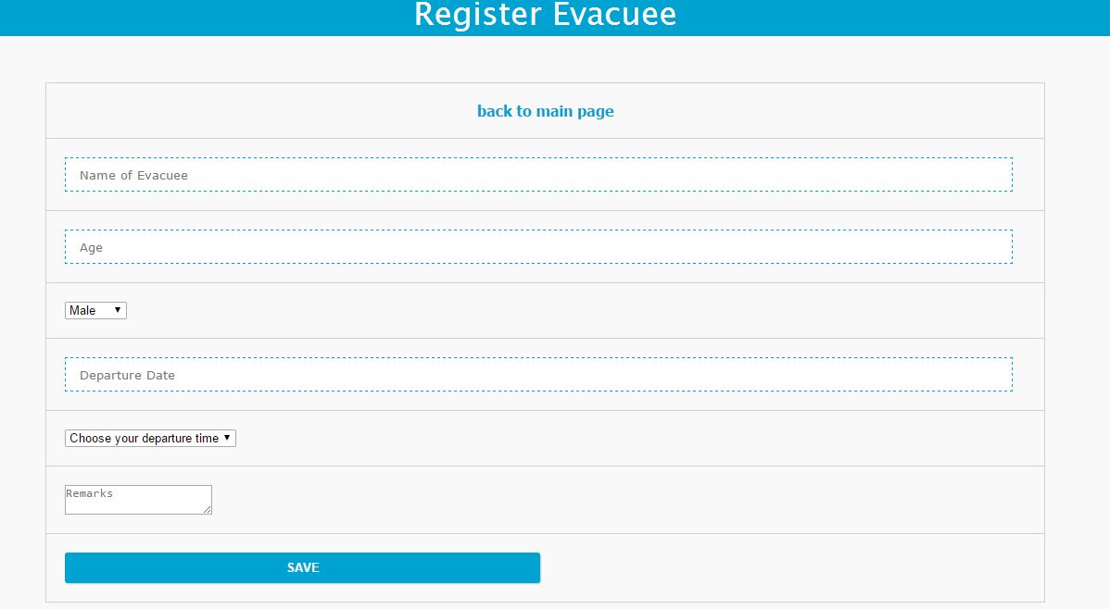

***UPDATE EVACUEES RECORD PAGE***

To gain access, the user must click the “pencil logo” on the left part column of “Operations”. Once the “Update” button is clicked, the old data in the list will be updated. This process is used to change records of a particular evacuee.

# 

***Programming Language used***

* PHP

***Database testing used***

* PhpMyAdmin using XAMPP server

***Software***

* Operating system (Windows 8 or 10)
* Atom & Sublime – Text Editor

***Hardware***

* Wi-Fi enabled device

# Conclusion

In conclusion, the team was able to implement these modules such as: Mapping, Request for tent, and Registration of Evacuees within three months. These features will provide accurate and detailed information that will help the managers to make smart actions regarding with requests and deploying evacuees to different camps/shelters.

# Lesson Learned

Based on our experience, a team must be willing to make big adjustments when it comes to time management and can adapt and deal to changes. As a group, we learned about mapping specifically in QGIS and Google Maps, how map is being implement in a website. Also, we’ve unlock the ability to conduct, report, and analyze a problem. Lastly, we learned about the difference between NoSQL and MySQL.

# References

* https://emergencymanual.iom.int/entry/19172/camp-coordination-and-camp-management-cccm
* http://digitaleducation.net/ndrp/wp-content/uploads/2016/09/C_CCCM-operation-protocol_20150207_EQT.pdf
* http://www.ehealth.ph/media/kunena/attachments/196/ManualonEvacuationCampManagementDraft1.pdf
* http://www.webpal.org/SAFE/aaareconstruction/immediate/refugee_camp.htm
* http://www.campetent.com/family-camping-tent-sizes.html
* http://www.campetent.com/tent-pads-and-tent-camping.html
* http://reliefweb.int/report/philippines/camp-coordination-and-camp-management-cluster-response-typhoon-haiyan-yolanda-11
* http://www.maca.gov.nt.ca/wp-content/uploads/2011/10/MACA_Public-Safety_Disaster-Financial-Assistance-Evacuation-Assistance-Guide_2011.pdf

# Appendices

## Appendix 1: Relevant Source Code

**See Github for the Source Code**

* https://github.com/amiel03/SOFTDEV-CAMP-COORINATION-AND-CAMP-MANAGEMENT

## Appendix 2: Proponents Resume



|  |  |  |  |
| --- | --- | --- | --- |
| **Name:** | **AMIEL KRISTIAN M. CUASAY** | |  |
| **Complete Address:** | 8235 Constacia St. | |
| Makati City | |
| **Contact Number/s:** | Landline: 899-06-58 | |
| Mobile No.: 09367473931 | |
| **Email Address:** | amcuasay@student.apc.edu.ph  amcuasay04@gmail.com | |
|  | |

|  |  |
| --- | --- |
| **Job Objective** | To have an internship in a company where I can hone my skills in code-writing, leadership, project management, oral communication and problem-solving. |
| Education | **Asia Pacific College**, Magallanes, Makati City  **B.S. Information Technology, with specialization in Mobile and Internet Technology**  June 2013 – present |
| **Work-Related Courses** | * Advanced Web * Applied Projects * Database Management * Introduction to System Development * Mobile Application * Programming Embedded System * Project Management * Quality * Software Development * System Analysis and Design * Technopreneurship * Web Programming |
| **Academic Projects** | **Camp Coordination and Camp Management – Disaster Response Team,** Jan. 2017  The main client of this group project is NDRRMC. The web-based prototype was completed within three months. The proponent was involved in conceptualization, analysis and development of the project.  **Sales Stalk,** Jan. 2017  This group project is a mobile based application that notifies potential customers when there is a sale near a mall or local store. The proponent’s roles/responsibilities are: analyst and designer.  **Golden Cup,** June 2016 – present  This group project is an E-commerce project that provides products and services to customers. The proponent’s roles/responsibilities are: project manager, analyst, designer, and developer. |
| **Technical Skills** | * Web Programming * Languages: PHP, Python, JavaScript, SQL, Bootstrap * Database Management * Front-end and Back-end development * MS Office: Word, Excel, PowerPoint * Develop Android Application |
| **Seminars & Trainings Attended** | * Programming the Future   Asia Pacific College, July 2016   * Security through Cryptography   Asia Pacific College, July 2016   * Xamarin Application Development Workshop, Asia Pacific College, July 2016 * DevCon, Asia Pacific College, September 2013 |
| **Extra-Curricular Activities** | * Microsoft Community, Member, 2016 * APC Flickers, Member, 2014-2015 * PWERSA, Member, 2013-2014 |

|  |  |  |
| --- | --- | --- |
| **Name:** | **MARY ALLYSON P. BANDONG** | **123.jpg**  **2x2 CORPORATE photo**  (must fit in this box) |
| **Complete Address:** | 10 Ilang – Ilang St. PAL Gate 2 Bgy. 184 Maricaban |
| Pasay City |
| **Contact Number/s:** | Landline: N/A |
| Mobile No.: (0935) - 659 - 5358 |
| **Email Address:** | [mpbandong@student.apc.edu.ph](mailto:mpbandong@student.apc.edu.ph)  [allysonbandong17@gmail.com](mailto:allysonbandong17@gmail.com) |

|  |  |
| --- | --- |
| **Job Objective** | To secure an internship in a company where I can utilize and improve my skills as an I.T. student specializing in mobile and internet, and to have an opportunity to gain more experience and knowledge about the I.T. industry. |
| Education | **Asia Pacific College**, Magallanes, Makati City  **B.S. Information Technology, with specialization in Mobile and Internet Technologies**  June 2013 - Present |
| **Work-Related Courses** | |  |  | | --- | --- | | * Applied Projects 2 * Mobile Programming * Project Management * System Analysis and Detailed Design 1 & 2 * Software Development * Software Quality Management | * IBM Descriptive Analytics * IBM Enterprise Data Management * IBM Fundamentals of Business Analytics * IBM Predictive Analytics | |
| **Academic Projects** | **“Camp Coordination and Camp Management”**, Data Viewing and Mapping Module, Software Development, January - April 2017  A software development project of mapping software specifically made for NDRRMC (National Disaster Risk Reduction Management). Tasks were equally divided and delegated to the three members of the project team.  The proponent was assigned as the project analyst, documentation controller and quality assurance specialist. The specifications and expectations were successfully met by the project team by the end of the term.  **“Project Golden Cup”**, E-Commerce Website, Applied Projects, January - April 2017  A software development project of an e-commerce website specifically made for Golden Cup Exim Marketing Corporation. The proponent was assigned as the project analyst and documentation controller. The proponent and project adviser oversaw the progress of the project. Eventually, the specifications and expectations were successfully met by the project team by the end of the term.  **“APC Lost and Found”,** Mobile Application, PBL Track,  September 2016 – December 2016  A mobile application developed by the project team for Asia Pacific College. Its main specifications include the necessary features aligned to the objectives of the program such as creating, deleting and updating of the items that are lost and found. The proponent was assigned as the project designer and documentation controller. The specifications and expectations were successfully met by the project team by the end of the term. |
| **Technical Skills** | |  |  | | --- | --- | | **Tools and Applications**   * Eclipse IDE, Android Studio, IntelliJ IDEA * MS Office (MS Word, MS PowerPoint, MS Excel) * MySQL Workbench, XAMPP | **Programming Languages**   * HTML5 * Java * C++ | |
| **Seminars & Trainings Attended** | * Office 365 Seminar, Asia Pacific College, July 2015 * C# / XAML Fundamentals: An Introduction to Developing apps in Visual Studio, Asia Pacific College, March 2015 * Android Workshop, Asia Pacific College, September 2014 |
| **Extra-Curricular Activities** | * Junior Philippine Computer Society, Member,   S.Y. 2013 – 2016 |

|  |  |  |
| --- | --- | --- |
| **Name:** | **KENTH WENDELL E. CURATO** |  |
| **Complete Address:** | 6097 Albert St., Poblacion |
| Makati City |
| **Contact Number/s:** | Landline: (02)791-67-37 |
| Mobile No.: (0998)-544-3776 |
| **Email Address:** | [kecurato@student.apc.edu.ph](mailto:kecurato@student.apc.edu.ph)  kent.curato@gmail.com |



|  |  |
| --- | --- |
| **Job Objective** | To have an internship in a company that will provide me a position where I can apply and develop my analytical, organizational, design, and code-writing skills. |
| Education | **Asia Pacific College**, Magallanes, Makati City  **Bachelor of Science in Information Technology with specialization in Mobile and Internet Technology**  June 2014 – present  **Bachelor of Science in Computer Engineering**  June 2012 – June 2014 |
| **Work-Related Courses** | * Applied Projects * Computer Organization * Computer Security 1& 2 * Data Networks * Database Management 1 & 2 * Enterprise Java * IBM Predictive Analytics * ICT Service * Information Security * Mobile Application * Mobile Programming * Programming Embedded Systems * Project Management * Software Development * System Analysis and Design 1 & 2 * Technopreneurship * Web Programming * Windows Server |
| **Academic Projects** | **Hardware and Equipment Management System,** June 2016 – April 2017  The main client of this group project is DCPI. The project is a web-based system that helps the client to easily access the equipment and accounts. The proponent’s roles in the group project are Project Manager and Documentation Specialist.  **Camp Management and Camp Coordination Web Application,** January 2017 – April 2017  The main client of this group project is NDDRMC. The web-based prototype was completed within three months. The proponent was involved in conceptualization, analysis, and documentation of the project.  **Sale Stalk Mobile Application,** January 2017 – April 2017  This group project is a mobile-based application that notifies potential customers when there is a sale near them. The proponent’s role is System Developer. |
| **Technical Skills** | * Mobile Development (Java) * Systems Analysis and Design * Embedded Systems Programming (Arduino) * Web Development (HTML, CSS, MySQL, JavaScript, PHP) * MS Office: Word, Excel, PowerPoint |
| **Seminars & Trainings Attended** | * Xamarin App Development   Asia Pacific College, July 29, 2016   * Office 365 Tips and Tricks   Asia Pacific College, July 27, 2016 |
| **Extra-Curricular Activities** | * Asia Pacific College Robotics Organization, Member, SY 2015-2016, SY 2013-2014 * Junior Philippine Computer Society, Member, SY 2014 – 2015 * Asia Pacific College Dance Company, Marketing, SY 2012 – 2013 * Asia Pacific College Association of Computer Engineering Students (ACES), Member, SY 2012-2014 |